CHAPTER 3

3.1 Proposed Work
The proposed system aims to develop an intelligent and real-time loan approval prediction model using machine learning techniques. In the current financial landscape, traditional rule-based loan approval systems are increasingly inefficient, slow, and prone to bias. These limitations often result in delayed decisions, inconsistent evaluations, and missed lending opportunities. To address these issues, the proposed work utilizes AI-driven methods capable of learning from historical loan data to make accurate, consistent, and timely approval predictions.
At the heart of the system is a supervised machine learning pipeline designed to automate the end-to-end loan eligibility evaluation process. This includes data collection, preprocessing, model training and evaluation, deployment, and real-time prediction via a web-based interface. The system uses a well-established dataset sourced from Kaggle, containing labeled loan application records, to simulate real-world financial decision-making scenarios.
The proposed methodology consists of the following key components:
1. Data Collection and Pre-processing
The dataset is sourced from trusted open-source repositories like Kaggle and contains demographic and financial attributes such as income, credit history, education, employment type, loan amount, and property area. Preprocessing steps include handling missing values, encoding categorical variables using label encoding and one-hot encoding, and standardizing numerical features. These steps ensure that the input data is clean, consistent, and suitable for training machine learning models.
2. Model Selection and Training
Logistic Regression is selected for its interpretability, simplicity, and effectiveness in binary classification tasks like loan approval. The dataset is split into training and testing sets to train the model and evaluate its generalization performance. Evaluation metrics such as accuracy, precision, recall, and confusion matrix are used to measure the model’s performance and ensure its suitability for real-world deployment.
3. Model Serialization and Deployment
Once the model has been trained and validated, it is serialized using the Joblib library for efficient reuse and deployment. A user interface is developed using Streamlit, which allows users to input applicant details and receive real-time loan approval predictions. The interface is designed to be simple, responsive, and intuitive, making it easy for non-technical users to interact with the system.
4. Real-Time Loan Eligibility Simulation
The deployed application simulates a real-time loan evaluation system where users can enter loan-related parameters and instantly receive feedback on the likelihood of loan approval. The model processes inputs dynamically and displays results within seconds. The application is tested thoroughly to ensure accurate predictions and responsiveness under various user input scenarios.
This proposed work demonstrates how machine learning can be effectively integrated into the financial domain to automate loan processing, improve decision accuracy, and enhance user experience, all while maintaining scalability and adaptability for future needs.

3.2 System Architecture:
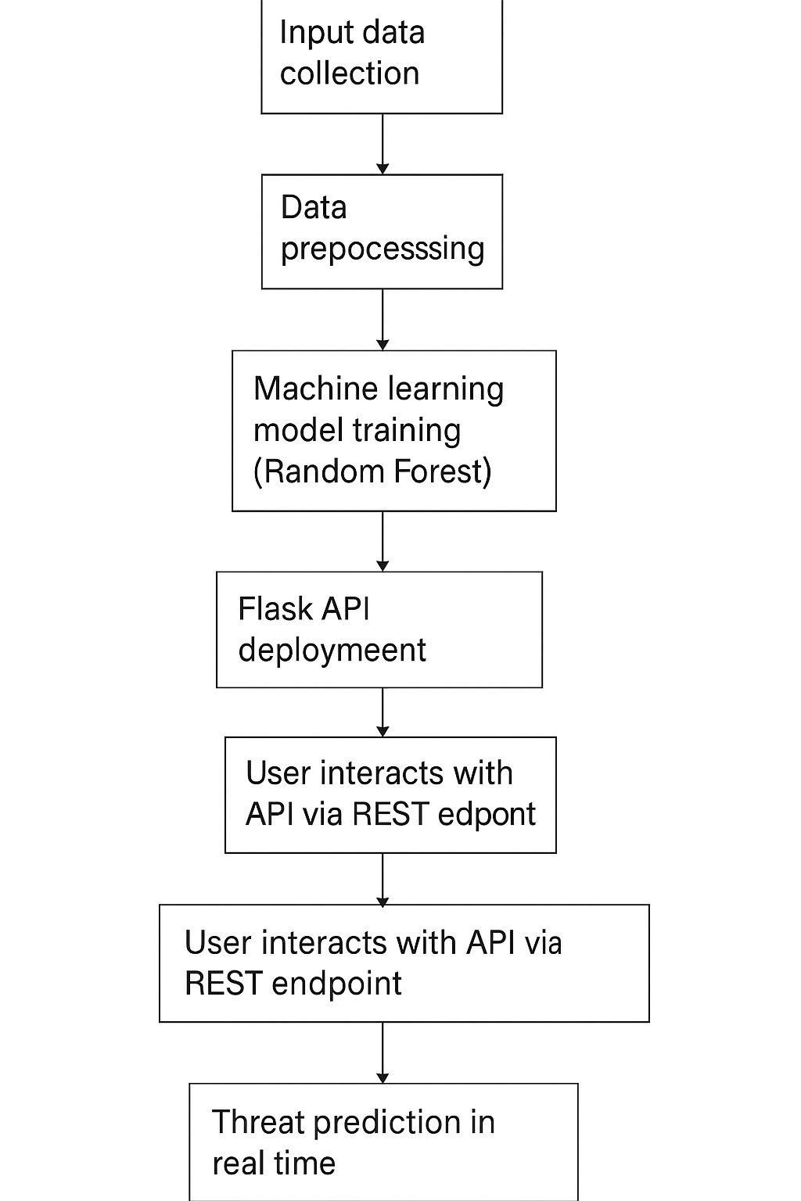
Fig 3.2.1 Loan Approval Prediction System Architecture
The system architecture for the loan approval prediction model begins with the collection of input data, which includes various attributes of loan applicants such as income, credit history, loan amount, education level, and employment status. This raw data is then passed through a preprocessing stage, where necessary steps like handling missing values, encoding categorical variables, and scaling numerical features are performed to prepare the data for model training.

3.3 Sequence Diagram: 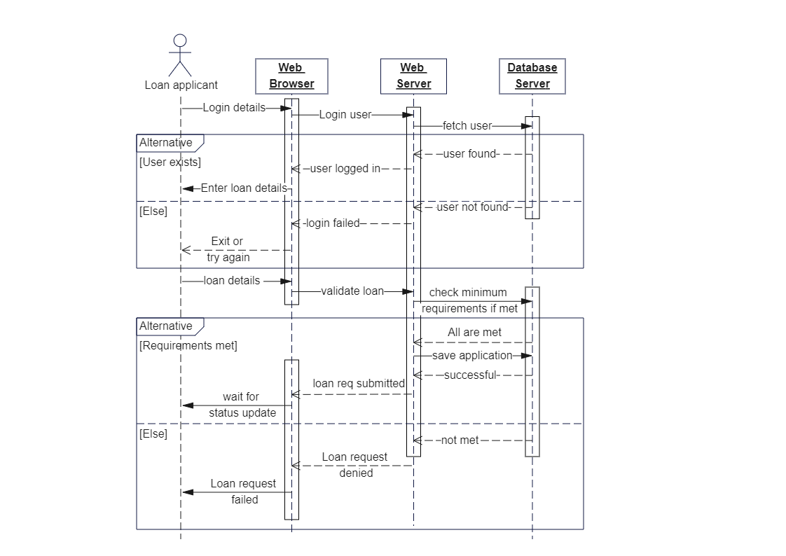 Fig 3.2.2 Loan Approval Prediction Sequence Diagram
In the proposed loan approval prediction system, the process begins when the user enters loan-related input data through the Streamlit-based user interface. This data is then submitted to the backend application (app.py), where it undergoes preprocessing and validation to ensure it is suitable for prediction. Once validated, the backend uses the trained machine learning model to analyze the input and generate a prediction. Based on the result, the user interface displays either a "Loan Approved" or "Loan Rejected" message. Optionally, the system can also log the prediction for future reference or analysis. This flow ensures a smooth and real-time interaction between the user, interface, backend logic, and machine learning model.
3.4 Data Flow Diagram (DFD):

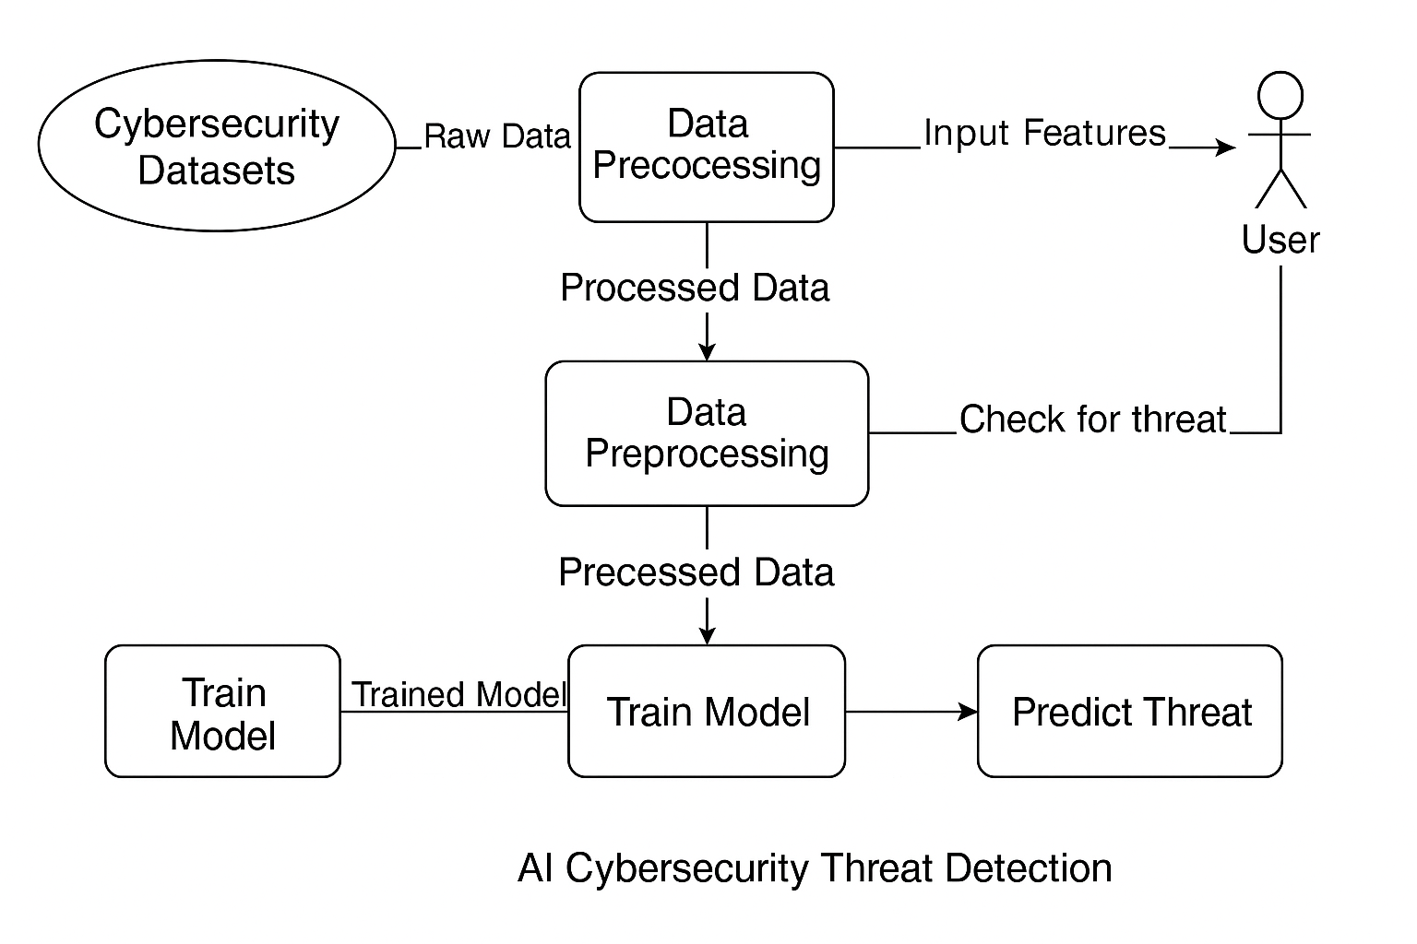
Fig 3.2.1 Data Flow Diagram for Cyber Threat Detection System

This Data Flow Diagram (DFD) represents the flow of data in machine learning based cyber threat detection system. The process starts with collecting row data from cybersecurity datasets, which is then passed through a data pre-processing stage to clean and structure it. The processed data is used to train a machine learning model capable of detecting threats. Users provide input features, which are also preprocessed and then checked for threats using the trained model. The system analyses the input and returns threat predictions to the user. This diagram highlights the interaction between users, datasets, preprocessing, and the prediction model in a streamlined manner.

3.4 System Modules
The proposed loan approval prediction system is designed using a modular approach to ensure clarity, maintainability, and scalability. Each module in the system performs a specific role, and together, they form a robust pipeline capable of processing input data, predicting loan eligibility, and delivering results in real time. This modular structure also facilitates future enhancements, such as integrating advanced algorithms, cloud deployment, or support for different loan categories.
The system begins with the Data Collection Module, which utilizes publicly available datasets (such as the Loan Prediction dataset from Kaggle). These datasets contain labeled records of previous loan applications, including applicant income, credit history, employment status, loan amount, and approval outcomes. This data serves as the foundation for training the machine learning model.
The collected data is then passed to the Data Preprocessing Module, which is responsible for cleaning and preparing the dataset. This includes handling missing values, encoding categorical variables (such as gender, education, and property area), and scaling numerical fields. Proper preprocessing ensures that the data is consistent and optimized for training.
Next, the Model Training Module uses the preprocessed data to train a Logistic Regression classifier. The dataset is split into training and testing subsets, and the model is evaluated using performance metrics such as accuracy, precision, recall, and confusion matrix. Once trained and validated, the model is saved using the Joblib library for later use during prediction.
The Prediction Module loads the saved model and uses it to evaluate new user inputs. The inputs undergo the same preprocessing pipeline to ensure compatibility with the trained model. Based on the analysis, the system predicts whether the loan should be approved or rejected.
To provide a user-friendly interface, the UI Deployment Module is developed using Streamlit. This web-based interface allows users to enter applicant details and receive immediate feedback on loan approval status. It acts as the front end of the system, making it accessible even to non-technical users. Finally, the Testing and Validation Module ensures the entire system functions correctly under various conditions.

